Proposal – Filtering’s practical application to pixel art.

Our Proposal is to “Study and experimentation of applying image Filters pixel art in order to produce useful visual effects.” The main thing that I would like to do with this is project is in-depth research into filters and how they are made in depth, and also see what if any current filters can be applied to pixel art / if we can replicate these effects in pixel art to allow for interesting art developments.

In case you do not know, pixel art is images in which the artistic design is seen at the pixel level. This is where the resolution of the art is low enough that you are able to individually select individual pixels out from the artwork, and each of the pixel has some form of meaning that is clear.

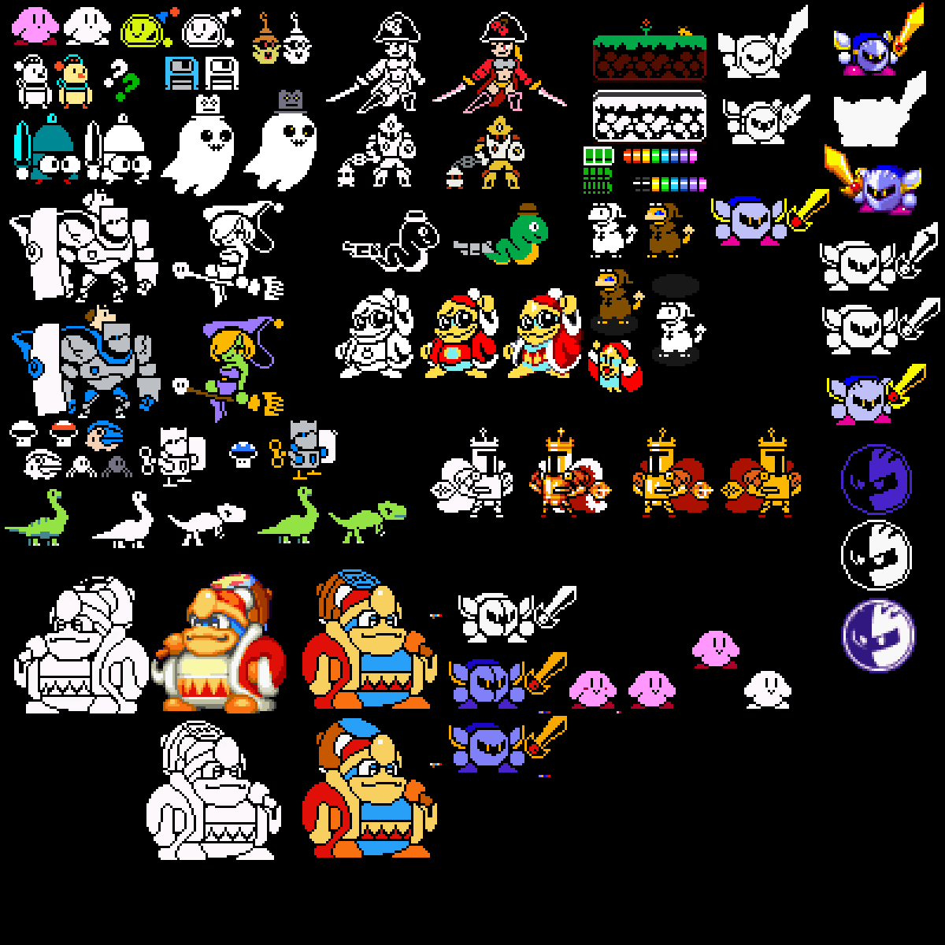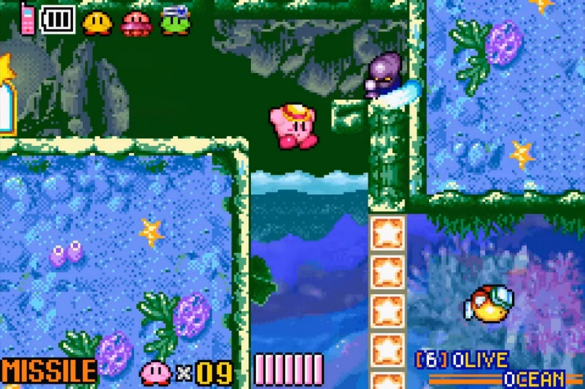

**Figure 1 - Pixel Art Examples**

To my knowledge, while filters are often used in many other forms of media pixel art has almost never used any filtering within any uses. As such, we are curious if there are any examples and uses for filtering in pixel art. Even if there is not, then why can’t they be useful? Perhaps even if there are known current uses, we could try and find the first uses. This project is meant to explore such questions by looking into pixel art and filtering history and examples, application of filters, and design of own filtering methods that could be useful to pixel art.

Currently, thanks to a bit of pre-research, what we are able to find when it comes to filters and pixel art, they are not really able to be used effectively if at all due to the nature of pixel art being made on the pixel level. This causes filters to have drastic effects that make the image to distorted to actually have much, if any, practical uses. As such the idea of this project is to try and experiment with pixel art and propose new ideas that may allow for pixel art to be able to take and use filters similar to how other higher resolution images use them.

It will also discuss the practical applications that theses filters can be used, for example if filters are able to be applied to even lower res versions of images it can be useful for speeding up applications by reducing the images quality to lower levels and then applying pixel-based filters. Also, games could use these to speed up the animation workflow of applications.

Overall, the point of this research paper would be study of what applications filters can have with respect to pixel art, and try to find practical uses be it technical or art based.

**Additional information –**

* While this will cover things such as gaussian and box filters, it is going to have to expand upon these ideas in order to find uses for them, as well as other filtering designs
* Will use multiple test images of varying pixel art styles and such for experimentations in order to see how filtering results apply to each image
* Will also led to designs of pixel-based filters, that could be used within applications and games.
* Will look both into history of pixel art and filtering and define the main information needed for both of these.
* Note, if possible, would at least prefer something to do with filters as I can see using these a lot in future design stuff.